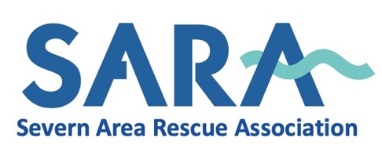

Membership Application

This form may be completed in Microsoft Word by typing next to the >. You can use ‘Tab’ to move to the next line
Surname: | >
Forenames:  (Known As) | >
Date of Birth: | >
Home Address:  (including Post Code) | >  >  >  >
Occupation:  (If applicable) | >
Work Address:  (if applicable)  (including Post Code) | >  >  >  >
Preferred Contact Telephone Number: | >
Email Address:  (Block CAPITALS) | >

Relevant experience: (click/tick as appropriate)
Boat | Hill Walking | Climbing/Mountaineering
First Aid | Communications | Another Rescue Team
Administration | Finance | Engineering/Maintenance
(If previously involved with another Rescue team, please give details on a separate sheet)

Details of other relevant certificated experience/ certificated qualification or skill:
>

If you are applying to become an operational member, are you confident in water? Insert YES or NO >

Brief Details of any relevant Medical Condition:
>

Do you hold a full UK Driving Licence? Insert YES or NO >

Please provide Name & Email Address of two Character Referees:-
Employer | Other
> | >
> | >

To which SARA Station do you wish to affiliate:
>

(See Over)

Statement of Motivation: (please outline below why you wish to join SARA and what you feel you can offer the Association.)

>

Please note that, following the recruitment process, SARA may conduct a background or DBS check

Date: -

When completed, please send by email to: info@sara-rescue.org.uk or by mail to:

SARA
The Lifeboat & Rescue Station
Beachley
Chepstow
NP16 7HH

